INTRODUCTION

- OpenGL is a low-level graphics library specification.

- Since OpenGL drawing commands are limited to those that generate simple geometric primitives (points, lines, and polygons), the OpenGL Utility Toolkit (GLUT) has been created to aid in the development of more complicated three-dimensional objects such as a sphere, a torus, and even a teapot.

- OpenGL provides a powerful but primitive set of rendering command, and all higher-level drawing must be done in terms of these commands. The GLUT and GLU (OpenGL Utility Library) libraries allow you to simplify your programming tasks.

- #include <GL/glut.h>
Note that glut.h guarantees that gl.h and glu.h are properly included for you so including these three files is redundant.

INITIALISATION

- glutInit(&argc, argv)
It should be called before any other GLUT routine because it initializes the GLUT library. The parameters should be the same as those to main()

- glutInitDisplayMode(GLUT_RGB | GLUT_SINGLE)
- Procedure to specify the display mode for a window: RGBA (GLUT_RGBA) or color-index (GLUT_INDEX) color model. The RGBA mode stores its color buffers as red, green, blue, and alpha color components. The fourth color component, alpha, corresponds to the notion of opacity. An alpha value of 1.0 implies complete opacity, and an alpha value of 0.0 complete transparency. In general, use RGBA mode whenever possible. RGBA mode is the default.

- Another decision you need to make when setting up the display mode is whether you want to use single buffering (GLUT_SINGLE) or double buffering (GLUT_DOUBLE). If you aren't using animation or 3D rotation, stick with single buffering, which is the default.

- glutInitWindowSize(int width, int height)
The arguments indicate the height and width (in pixels) of the requested window.

- glutInitWindowPosition(int x, int y)
Used to specify the screen location for the upper-left corner of your initial window. The coordinates are relative to the upper left corner of your system.

CREATING A WINDOW
- glutCreateWindow("Window name")
Used to actually create a window with the previously set characteristics of display mode, size and position. The command takes a string as a parameter which appears in the title bar of your window.

DISPLAY FUNCTION

- glutDisplayFunc(func_name)
The argument of glutDisplayFunc() is the function that is called whenever GLUT determines that the contents of the window needs to be redisplayed. Therefore, you should put all the routines that you need to draw a scene in this display callback function.

MAIN LOOP

glutMaiLoopn()
The program will now be able to handle events as they occur (mouse clicks, window resizing, etc). In addition, the registered display callback (from our glutDisplayFunc()) is triggered. This causes repeated refreshing of the screen and once this loop is entered, it is never exited.

CLEARING THE WINDOW

glClearColor(R,G,B,A)
Clears the color buffers and sets the background color.

glClear(GL_COLOR_BUFFER_BIT | GL_DEPTH_BUFFER_BIT)
We actually clear the screen with the glClear() command.The color buffer is what holds the color information for every pixel on-screen - if we want to clear the screen, we obviously should clear this one. However, if we're working in 3D, we want to clear the depth buffer.

2D CO-ORDINATE SYSTEM AND CLIPPING AREA

The openGl coordiante system corresponds to the everyday Cartesian coordiante system.
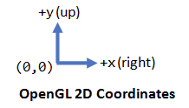

Clipping area refers to the area that can be seen (i.e., captured by the camera), measured in OpenGL coordinates.Objects outside the clipping area will be clipped away and cannot be seen.

- The default OpenGL 2D clipping-area (i.e., what is captured by the camera) is an orthographic view with x and y in the range of -1.0 and 1.0, i.e., a 2x2 square with centered at the origin.
- The function gluOrtho2D can be used to set the clipping area of 2D orthographic view.
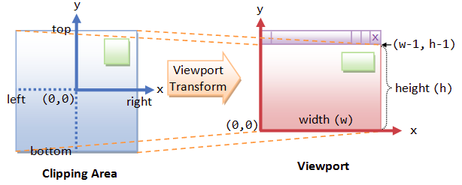
gluOrtho2D(Xmin,Xmax,Ymin,Ymax)

POINTS, LINES AND POLYGONS

- Each geometric object is described by a set of vertices and the type of primitive to be drawn

- glVertex[ntv]()
n: The number of dimensions (2,3 or 4)
t: The data type: i -> int, f -> float, d -> double, s -> short
v: To specify that the arguments are in a vector format.

This function is used to specify the coordiantes for drawing vertices.

- glPointSize(int size)
Used to control the size of the vertices. The argument supplied is the desired size in pixels. The default is as 1 pixel by 1 pixel point. If the width specified is 2.0, the point will be a square of 2 by 2 pixels.

- glBegin(mode) and glEnd()
glBegin and glEnd delimit the vertices that define a primitive or a group
of like primitives. glBegin accepts a single argument that specifies which
way the vertices are interpreted.
- glColor3f(R,G,B) [In general, it is glColor*() ]
First, the colour of the object is specified and then the object is drawn. Until the color is changed, all objects are drawn using that color.
- glFlush()
It is important to note that OpenGL commands are not necessarily executed as soon as they are issued.glFlush() is generally called at the end of a sequence of drawing commands to ensure all objects in the scene are drawn.

